Opening an imported project on NetBeans IDE

1. Locate the zip file. In my case, it is saved on the desktop.



1. Open NetBeans IDE
2. Click “File”, then “Import Project”, then select “From ZIP…”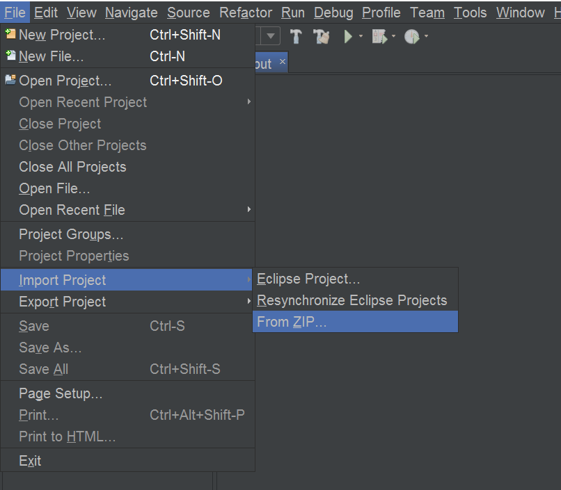
3. Click “Browse” and lookup your zip file. Once you find your file, select it and click “Open”. 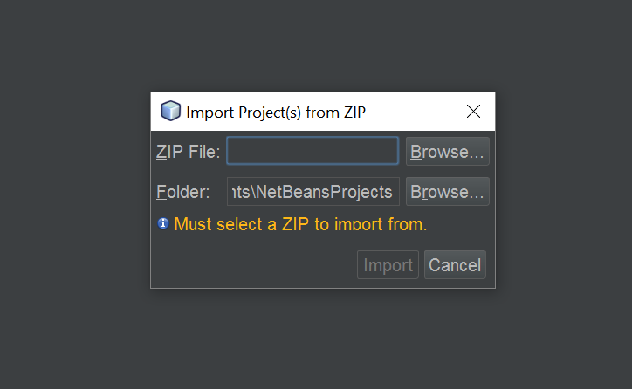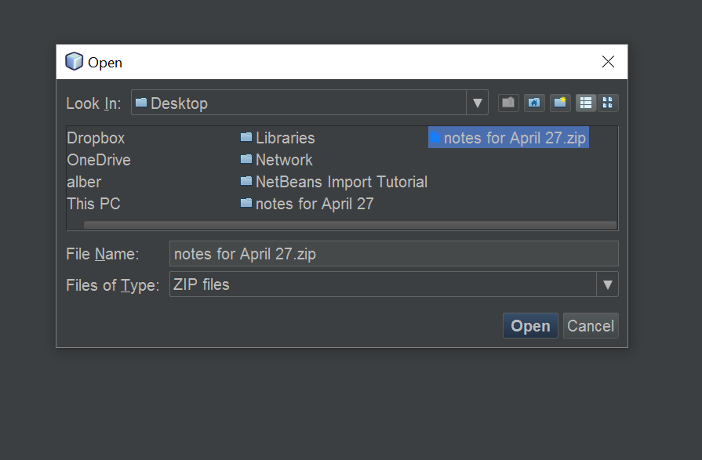
4. You may get a message saying, “No NetBeans projects added”, but that’s not a problem.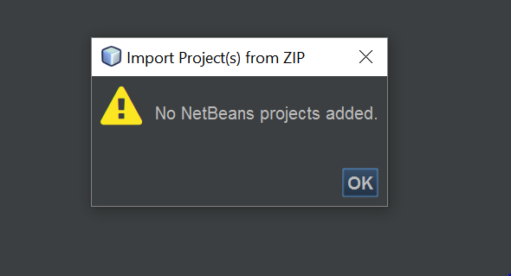
5. Click “File”, then click “Open Project” 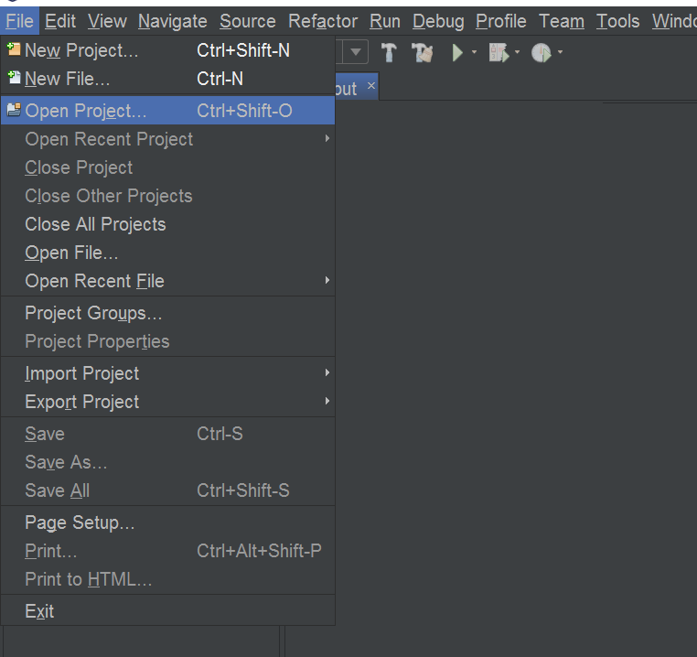
6. Your imported project should appear in your NetBeans Projects folder. Select it and click “Open Folder”. 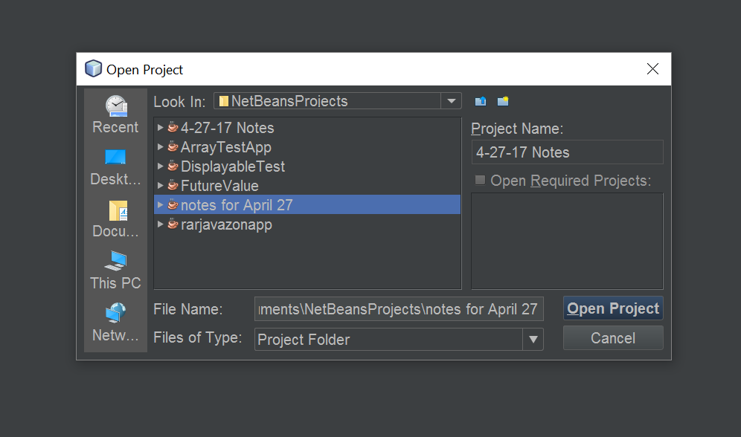
7. You should now see your imported project on your project list in NetBeans.